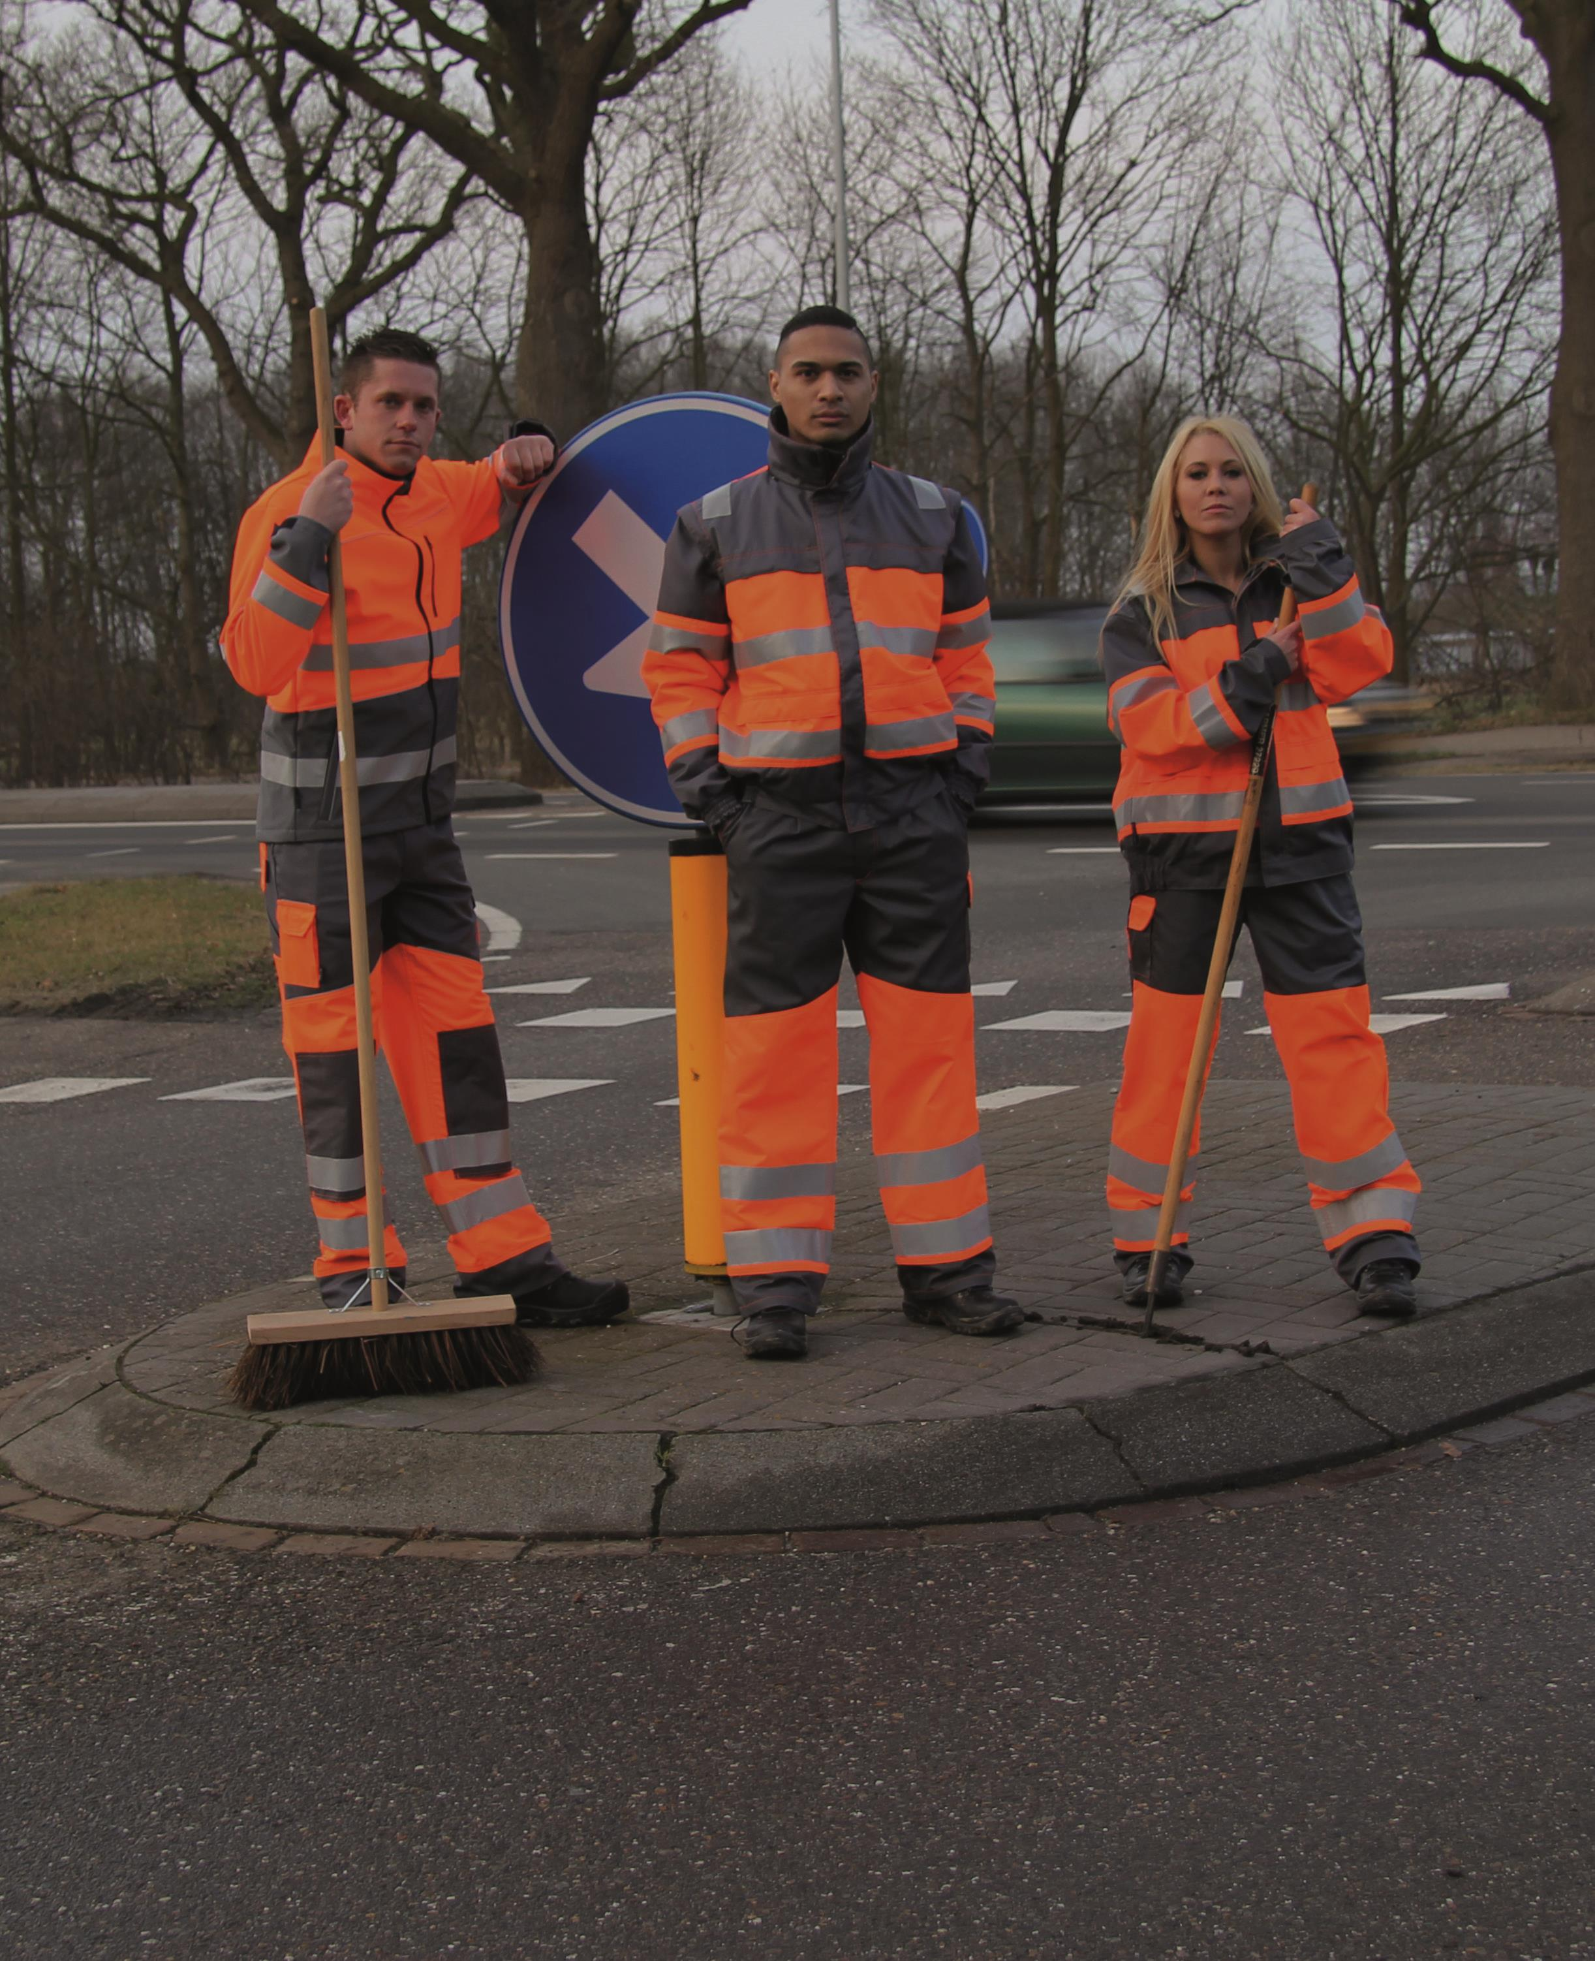
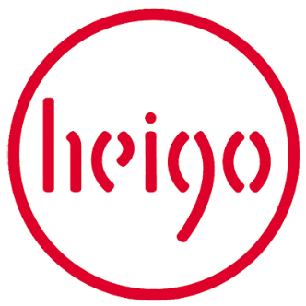

Social Report
www.heigo.nl
Start date membership
September 2005
Reporting period (financial year)
01-01-2018 - 31-12-2018

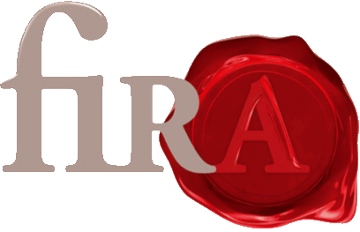
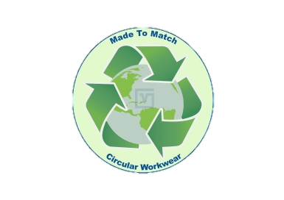

Contents

Summary: goals & achievements 2018 3
1. Sourcing strategy 7

1.1. Sourcing strategy & pricing 7

1.2. Organisation of the sourcing department 7

1.3. Production cycle 7

1.4. Supplier relations 7

1.5. Integration monitoring activities and sourcing decisions 8
2. Coherent system for monitoring and remediation 9

2.1. Factory A/Country A 9

2.2. Factory B/Country B 12

2.3. External production 12
3. Complaints handling 12
4. Training and capacity building 12

4.1. Activities to inform staff members 12

4.2. Activities to inform agents 13

4.3. Activities to inform manufacturers and workers 13

5.Information Management 14
6. Transparency & communication 15
7. Stakeholder Engagement 15
8. Corporate Social Responsibility 15
Organisation chart

Summary: goals & achievements 2018
Describe what you have achieved in the past financial year in terms of implementing the FWF Code of Labour Practices along your supply chain.
-During 2018 we created in Bulgaria in our Varna Confectia factory a Fair Wear Team, the Fair Wear Team is monitoring the social compliance and is responsible for the improvements in Social Compliance in the factory. During meetings the Fair Wear Team is monitoring the Social Compiance and making steps to improve Social Compliance in the factory. We see already results and progress for example the awearness of Fair Wear and and awearness in social compliance is rising in the factory among the employees especially on the workfloor. Ideas are coming by the workers how to improve working conditions and how to improve the social compliance in general. We are satisfied with this improvements and we are also waiting for the Audit reports from Fair Wear. During the coming period audit will take place in the Varna Confectia factory in Bulgaria.
What did we achieve more in 2018 -We achieved that all our suppliers of own production and also external suppliers have updated the FWF Questionnaire and also updated the photos in their production facilities of the latest version of the FWF Code of Labour Practices. We also explained and discussed with each individual manufacturer and supplier the Questionnaire and also the FWF Code of Labour Practices to understand if everything is clear for the manufacturers/suppliers. We achieved results in terms of higher and improved commitment from manufacturers and suppliers in implementing the FWF Code of Labour Practices. We achieved results and higher and improved commitment along our supply chain in terms of reasonable hours of work , no discrimination in employment, no exploitation of child labour, employment is freely chosen. We also achieved that complaints@fairwear.org is accepted and implemented by the suppliers. Also in the own production Varna Confectia we achieved that their is higher and improved awearness about the FWF Code of Labour practices among the management, staff and workers as already explained above. We are proud of these steps and improvements internal in our factory in Bulgaria
During the year 2018 we bought more from other FWF members like Tricorp, Texowear , Havep, Greiff. We also have moved production and purchase from non FWF members to our own production location in Bulgaria Varna Confectia. And we moved production from Far East to Varna Confectia in Bulgaria. We moved purchase in corporate wear to FWF member Greiff and to polen as low risk country. We also started a durable and longterm business relationship with Fristads also member of Fair Wear. We want to work with Fristads in a close partnership.
Include a statement from the most senior decision maker of the organisation about the relevance of improving labour conditions to the organisation and its strategy.
Mr Piet Goossens statement: Improving labour conditions is not any longer a dream it is a strategy and durable philosophy in our company. Improving labour conditions is becoming part of our daily processes in the company and part of our daily business. Not only in Heigo but also in our factory in Bulgaria Varma Confectia. Besides this clear statement is that Heigo wants to be one of the first workwear companies in Holland starting and implementing a living wage project! improving labour conditions to the organisation and its strategy is part of our company DNA. Not only in the own production facility in Varna Confectia but among our complete supply chain and among our complete Heigo team in elst Holland. Besides that improving labour conditions must be part of our company DNA also the economic and commercial part are becoming more and more important to offer the customers continuous higher level of improving labour conditions. This is not any more a wish from the customer/market to do business with Heigo it is coming a claim and requirement from the customer/market. Special the government market is asking for improving the Social performance/compliance and this is our core business.
Describe broader trends affecting the organization’s sustainability strategy.
-Sustainability in specific circularity is affecting our organizations sustainability strategy. Market and specific the government market is asking more and more for sustainable products like circular workwear. Awearness of consumers , buyers and public in general specific in the government market is affecting our sustainability strategy. Sustainability is part of our daily business not only in products , not only in the internal organization but also in our marketing and sales approach
-See for this point also the information above. The customer/market is claiming/require a complete and wider scope of the sustainability strategy. This need has a positive effect on our sustainability strategy. Not only the ILO part(the labour part) is important but also the sustainability of the fabrics and raw materials is becoming more and more important. But also circularity of clothing is coming more and more important. the return service programm is becoming important. But also energy, waste etc is becoming more important. that’s why we are also ISO 14001 certified besides ISO 9001. And we are also FIRA certificated to measure our performance level in sustainability. We reached the Fira Silver status with a extended audit report. We are also member of MVO
Briefly list key events, achievements and failures during the reporting period related to social compliance.
-One of our achievements is that we created a Fair Wear Team in our own production in Bulgaria Varna Confectia. As explained before we already see first results and improvements on Social Compliance in our own factory in Bulgaria. 2018 but also 2019 we will continuing with this systematic approach by monitoring our Social Compliance in the own factory in Bulgaria. the Fair Wear Team has becoming a important key in our
-If we look internal in our company than we achieved much more and higher awearness about FWF and about the FWF Code of Labour Practices among our complete staff of around 50 employees. During our weekly Monday lunch meeting we keep our staff updated about information/news/developments relating to Social compliance. Also achievement in 2017 is that we join the Convenant Sustainable Clothing and Textiles which is also supported by the Fair Wear Foundation and we fulfill all requirements. If we look to our own production facility in Bulgaria Varna Confectia we worked hard on the CAP in 2017 to fulfill all the requirement and solve and improve all the remarks as mentioned in the CAP. We made efforts and achieved results to get the production in Bulgaria on the required level in terms of Social Compliance. We are proud of this because the own production in Bulgaria is the key producer/supplier in our complete supply chain.
Also achievement in 2018 is that we continued our study on living wages in the different production countries and we studied also specific living wages in Bulgaria. We are proud of it that the wages in Bulgaria are growing step by step more to the living wage level so that also in the near future we can start a living wage project in Bulgaria at Varna Confectia. We also discussed this before with FWF that our goal is to start a living wage project in our own factory in Bulgaria Varna Confectia. This is the target to start a living wage project in our own factory in Bulgaria Varna Confectia.

-Failings: As mentioned before we are still study the possibilities to start with a living wage project. We are making progress and we think that we have our strategy clear how to implement in a systematic and succesfull way a project towards living wage. Up to now we could not start up a living wages project in our own production in bulgaria. Even that we studied the living wage and we have good picture on the living wage in Bulgaria we did not start up a pilot project in living wage in Bulgaria. For 2019 this is our main goal to start with a living wage project in Bulgaria Varna Confectia. This project could be succesfull because we have controle in Bulgaria in our own factory over the main processes, figures and circumstances. As mentioned before we are stud.
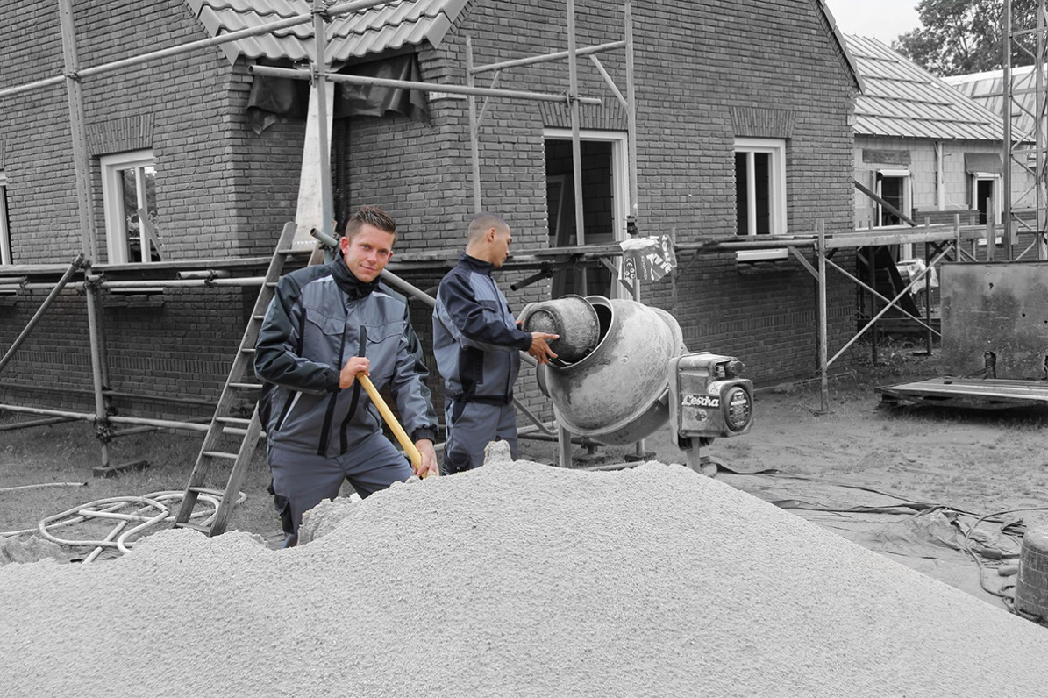
- Sourcing strategy
  - Sourcing strategy & pricing
Our sourcing strategy is to focus on our own factory Varna Confectia in Bulgaria and besides this our sourcing strategy is to buy as much as possible from other FWF members. Also our strategy is to produce as much as possible in low risk countries like Portugal if we cannot produce the product in our own factory in Bulgaria. Our strategy is also to move production from Far East to Europe and specially to our own factory in Bulgaria and low risk countries like Portugal for knitwears.
For potential new suppliers we focus if they are already member of FWF. FWF members are our prefered suppliers. In 2018 heigo implemented a durable and longterm partnership with Fristads/Kansas and we are working on a longterm partnership with Fristads/Kansas for the future. Besides our own factory Varna Confectia also Fristads Kansas became a strategic longterm partner for Heigo in workwears. One of the reason for this is that we focus on current FWF Members.
Our sourcing strategy is also more focused in 2018 on sustainability like more sustainable fabrics and sustainable raw materials. Focus is also on more suppliers within European Union for fabrics and raw materials for reasons of sustainability in terms of for example less CO2 emissions during transport , environmental circumstances in the production locations, but mainly also to respect the FWF Code of Labour practices in all stages of the production processes for fabrics and raw materials.
  - Organisation of the sourcing department
Organisation of the sourcing department is in hands of our purchase department with supervision of the management. Supervisor is director and owner of the company Piet Goossens. Purchase department is Johan Peters, Sandra Meeuwsen, Harold Zoet and Kay Thomassen.

  - Production cycle
The productcyclus is over many years. This is different for each style and collection and is influenced by new developments/trends in combination with demands from the market. We developed circular workwear with view on MVO and corporate social responsibility. This circular workwear can be recycled continuous and Endless. In Varna Confectia we use a lead time between 8 – 12 weeks. At varna confectia the factory is already informed about orders during the development of the article/collection. Varna Confectia is involved in the development of articles and collections from the beginning. For other suppliers we use lead times of 8 – 10 weeks.

  - Supplier relations
Describe whether you have selected new suppliers last year. if so, describe the selection process of new factories.
Last year 2017/2018 we selected Fristads/Kansas as a new supplier. This process was already started in 2016 but was more effective in 2017/2018. During the selection process membership of FWF was very important for us. Besides Varna Confectia we sourced for a second main supplier for workwears and we discussed with Fristads/Kansas and with Havep about a potential partnership. At the end we selected Fristads/Kansas as one of our key suppliers for the future in workwears. Important topic in this selection was the membership of FWF form Fristads/Kansas.
In 2018 we also start discussions with Teamdress for a longterm partnership for the furture. During these discussions it was also important that Teamdress has the intention to be Fair Wear member for the future. Still we are in this process and latest information was that Teamdress will become member of Fair Wear Foundation. This is perfect fitting in our strategy to buy as much as possible from other Fair Wear members. For corporate clothing our strategy is to buy from Greiff and to buy from Teamdress. Both Fair Wear memebers.
Our focus on selecting new suppliers is among the current FWF members.
Ofcourse instead of new suppliers our main focus and strategy is on producing more and more garments/workwears in our own factory in Bulgaria Varna Confectia. Instead of looking for new suppliers first we look if we can produce the garments also in our own factory in Bulgaria Varna Confectia.
.
In case you have terminated relationship(s) with supplier(s) last year, describe the process and reasoning behind it.
We did not terminated a relationship with a supplier last year.
  - Integration monitoring activities and sourcing decisions
Describe the way in which (the outcomes of) your monitoring activities influenced your sourcing strategy in 2018.
-We decided to buy more and more workwear from suppliers like Tricorp, Hydrowear Fristads and Bestex. We monitored the brand performance check of Tricorp, Hydrowear Fristads and Bestex and decided to increase the purchase volume at these suppliers. From Tricorp and Hydrowear the volume is already increased in 2018. Fristads and Bestex we start business in 2017/2018 we will increase the purchase volume during 2019. Clear strategy is to buy more and more workwear from other Fair Wear members. Clear strategy is to produce more workwear in our factory in Bulgaria and clear strategy is to produce more knitwear in low risk countries like Portugal.
State how supplier code performance was connected with sourcing decisions, including policy for termination and selecting new suppliers.
-Because of the situation in turkey we decided to move production to Portugal as low risk country and we decided to buy more workwears for suppliers like Tricorp , Hydrowear and other FWF members

When tensions arise between the prevention or mitigation of impacts related to a salient issue and other business objectives, how are these tensions addressed?
Does not apply
- Coherent system for monitoring and remediation
  - Factory A/Country A
Describe per country (one country per paragraph) and per factory¹ your monitoring activities and outcomes and how you followed up on Corrective Action Plans. Also describe how workplaces are selected for auditing.
Our own factory in Bulgaria:
-Bulgaria – 7 visits in 2018 to Varna Confectia visited by Piet Goossens
-87% of our total production is sourced from Varna Confectia
-During factory visits during the year 2018 Piet Goossens discussed the progress of the corrective action plan, code implementation, informing staff. We created a Fair Wear Team in Bulgaria for monitoring Social Compliance of our factory.
-the factory has been audited several times latest in 2016. During coming period 2019 our own factory Varna Confectia will be audited by Fair Wear.
-Because this is our own factory other clients are not involved in corrective actions.
-See detailed audit report and CAP for Varna Confectia 2016
-Yes there is a CAP, We can provide a complete overview of all the corrective actions which have been solved in 2017/2018 , we can provide and show all this information during the coming brand performance check. During coming brand performance check we will present a complete overview of the corrective actions we solved during the year 2017/2018.
Summary of how we follow up the CAP: -Varna Confectia has special team involded with the FWF Code of labour pratices. This team called Fair Wear Team is responsible in continuous improving the social compliance of Varna Confectia. This teams is responsible for the corrective action plan and responsible for the requirements/recommendations in the CAP. For exemple: Varna Confectia established a system to monitor and improve social compliance. The management organize a training to explain the workers about the aim and meaning of the FWF Code of Labour pratices. The management established a way of effective communications with workers, through information board postings, regular meetings. Varna Confectia establish an effective written grievence mechanism and train the workers on how to use it. Varna Confectia informs workers about the possibility to elect worker representatives, in a management-free meeting and voiting process. Varna Confectia established a transparent and detailed system how the salary is formed and explained this system to the workers. Varna Confectia want to start with a living wage project. Varna Confectia has official documentation from the Fire Bridage for Safety and Health circumstances in the factory. Each worker has a individual contract with Varna Confectia with all details in the each individual workers file. All requirements/ recommendations in the CAP have been handled and implemented in the Varna Confectia factory.
WEP training is given by Fair Wear in the factory Varna Confectia during last period.
Report the most important findings per FWF labour standard. See the guidelines.
-Employment is freely chosen. We do not have home working in our factory in Bulgaria.
-There is no discrimination in employment and no any gender based discrimination. More detailed information we can provide and show during the brand performance check
-No exploitation of child labour. All employees in the factory have contracts and part of the contract is a copy of the ID from the employee. So we can see exactly the age of the employee on the ID and be sure their is no child labour involved.
- During the brand performance check we will present and show exactly our policy and practices regarding wages and payments. During 2018 we discussed with FWF further about our goal to start with a living wage project in our factory in Bulgaria Varna Confectia. We studied the Living wage figures for Bulgaria and we see opportunities to start and implement succesfull a living wage project in Varna Confectia.

-No excessive working hours. Working hours are from Monday till Friday 8.00 – 17.00 oclock. Overtime is only needed if we have more orders and definition of overtime is working time after 17.00 oclock and on Saturday. Working hours on Saturday is also definite as overtime. Our production capacity has been in 2017 on such a sufficient level that there is nearly no need for overtime work. Our actions to prevent excessive and forced overtime are that we increased the production capacity and increased the number of employees. We changed some operations in the factory with the result of more efficiency and output. We changed the production planning and increased the leadtimes of orders from 6 weeks to 8 -10 weeks in general. Result of these actions is that there is nearly no need for overtime work.

Specifically about the use of the FWF Wage Ladder: what conclusions can you draw from the Wage Ladder?
-FWF wage ladder we used for the own factory in Bulgaria Varna Confection and our conclusion this that we are in the correct process and on the correct track for wages in Bulgaria. Difference between the actual wages for the employees and the living wage for Bulgaria is not so big difference anymore in Bulgaria.

For monitoring our own factory in Bulgaria Varna Confectia we used the Bulgaria Country study 2016. this country study is effective tool and provide relevant information we used for monitoring Varna Confectia. The country study provide relevant information of the industry, labour law, labour conditions and relations within bulgarias textile and garment industry.

Bulgaria - 1 visit in 2018 to Maiatex visited by Piet Goossens
We increased the prices for Maiatex during 2018 so that they can continue work and produce our orders. We pay all the invoices immediately after shipment so that they can pay the workers on time. We give them block/forecast orders so that they can make their own continuous production plannings for every 4-6 months time. Result and outcome is that they do not need overtime anymore for our production orders. We started with this way of working in 2016 and continued in 2017 to give forecast for every 4-6 months time. This works perfect. FWF Code of Labour Pratices have been discussed in detail with the management of Maiatex. Also complaints@fairwear.org has been discussed so that workers can send complaints in a confidential way.

Portugal - 1 Visit in 2018 to Ultra Creative visited by Piet Goossens. Also owner of Ultra Creative (Antonio Ferreira) visited our company during august 2018 during his business trip in Holland
Production location has been visited and inspected by Mr Goossens both the sewing factory and also fabric processing factory. Also production plannings have been discussed. Ultra-Creative increased the number of employees and increased the production capacity in term of machinery. Also we agreed on a leadtime of 8 weeks instead of 6 weeks. Result and outcome is that they do not need overtime for our orders. Also we agreed on increased prices in 2017 for the garments we produce at Ultra Creative, reason is increasing wages in Portugal and the social responsibility from the manufacturer to the employees. FWF code of labour practices have been discussed in detail with the owner Antonio Ferreira of Ultra Creative. Also complaints@fairwear.org has been discussed so that workers can send complaints in a confidential way. Owner Antonio Ferreira is committed to implement the FWF Code of labour practices in the factory. Really good to see that in Portugal the commitment and awearness of FWF Code of Labour Practices is growing. Also antonio Ferreira is considering a membership of FWF for the near future.

Portugal - 1 visit in 2018 to Barlope visited by Piet Goossens
Social and financial situation in Portugal and special at Barlope factory has been discussed with the management of Barlope and with agent Carmo Saraiva. Situation in Portugal is hard for manufacturers , increasing wages and social responsibilities are reason for increasing price levels in Portugal. Also we agreed on increasing prices in 2017 to Barlope. Production factory has been visited an inspected by Mr Goossens. Also we agreed to give more forecast purchase orders so that they are free to make their own production plannings. Result and outcome is that the they can make their production plannings more efficient and without overtime to finish our orders.

Hungary – 1 visit in 2018 Body Wear Kft. Visited by Piet Goossens. Wages and social responsibility are increasing in Hungary. Result is that purchase prices have been increased for the garments in 2018. Also we agreed on increased purchase prices in 2018 to Body Wear. Factory has been visited and inspected in hungary by Piet Goossens. We send more forecast orders to Body Wear so that they can prepare their own production planning in a more efficient way. FWF Code of Labour practices have been discussed with the management of Body Wear and also complaints@fairwear.org has been discussed so that workers can send complaints in a confidential way. Besides our visit the owner of Body Wear Mr Andre fleer visit also our company during October 2018

China – 1 visit. Mr Cutizen form Mingyide Co Ltd visit our company in 2018. We discussed in detail with Cutizen abour our membership of FWF and we discussed in deatai FWF Code of Labour practices and also complaints@fairwear.org.Labour conditions in china are becoming more and more important and also wages are increasing in china. Also we agreed on increasing prices for the garments we buy form Mingyide Co Ltd in 2018. Not only labour conditions are more and more important in china also environmental and Safe and healthy working conditions are became more and more important in 2017.

  - Factory B/Country B
For other countries this was discussed during the annual supplier evaluations.
  - External production
-Meetings during 2018 with other FWF members like Hydrowear, Fristads/Kansas, Tricorp, De Berkel, Suit Supply, Greiff , Bestex. During these meetings the FWF membership has been discussed as important part of our relationship with these suppliers. Brand performance check of these suppliers has been discussed during the meetings and also CAP have been discussed during these meetings. External production supplier we received uptodate questionnaires and we received photo from the FWF Code of Labour Practices in the production facilities. With the external production suppliers we discussed the FWF Code of Labour Practices during the yearly performance check with these suppliers. Important part of the yearly performance check with the external production suppliers is the Social performance of these suppliers in 2018.
- Complaints handling
In case there were complaints received at your supplier(s) please describe how you dealt with the complaints.
-no complaints received during 2018
Describe what you have done to make sure workers at your suppliers are aware of the FWF complaint mechanism.
-In Varna Confectia the complaint mechanism is explained by the Fair Wear Team in detail to the workers.
-At all other manufacturers and suppliers the FWF complaint mechanism was discussed between Heigo and the management of the manufacturer / supplier.
Report on the policy for receiving, investigating and responding to grievances and complaints.
Is there a system in place to post and monitor information regarding complaints? Have you investigated if the root causes of the complaint are present in other factories, and if so taken corrective action?
Have you revised your sourcing/monitoring practices to address root causes of received complaints?
- Training and capacity building
  - Activities to inform staff members
The board is informing and train the management and staff members during meetings about the FWF membership and about the MVO strategy. The management and staff is asked to give their suggestion about the FWF membership.
Beginning this year 2019 we organized a Fair Wear sales training for our complete sales team. Emma Conos and Anouk Post gave this training/presentation. Result is that the awearness about FWF and our social compliance is rising in our sales team. Social Compliance is now part of our daily communications between the Heigo sales team and the customers.
During our weekly Monday lunch meetings all staff is informed up-to-date about latest information/news/developments about the FWF membership. Monday lunch meetings we use to inform, train our staff and to show transparency. With the Monday lunch meetings we achieve higher and improved awearness among all staff about our FWF membership and about our FWF activities.
Also during sales meetings with our sales team we explain them the Code of Labour practices and we inform our sales team about our FWF activities among the supply chain and inform them how to inform customers about our FWF activities. It is important that all our employees but specially also the sales staff can inform the customers/the market about our FWF activities. This is also the reason that for the coming period we ask FWF to give and organise a internal FWF training to our Heigo staff members and sales team to update and improve our knowledge about FWF , about FWF code of labour practices, about living wages, about FWF activities.

  - Activities to inform agents
Heigo works with one agent in Portugal this is Carmo Saraiva. Carma Saraiva is working for many years for Heigo as a agent as Carmo Saraiva is well known with the FWF Code of labour practices, questionnaire and well known with the social compliance we ask from our suppliers etc.
  - Activities to inform manufacturers and workers
Describe activities undertaken to inform and train manufacturers and workers. In case you have participated in any of the trainings FWF offered, please describe the process and results.
All selected manufacturers are workers are informed about the FWF Code of labour practices and also during the yearly visits the FWF Code of labour practices is part of the meeting and part of the evaluation with the supplier. Social compliance and Social performance is part of the yearly evaluation with the manufacturers / suppliers.
During the meetings /evaluations we also offer our support and help to the manufacturers/suppliers
Describe strategy and scope of efforts to strengthen capacity of management, workers and other staff to improve in social performance.
For other FWF members. Strategy is that every year during the evaluations we check if FWF members are still member of FWF and we discuss with these members the FWF membership. We check the brand performance check from these FWF suppliers and we want to know their progress.
Social performance is part of our company DNA. Besides that we keep management , workers and staff members at Heigo updated during weekly lunch meetings we also use other tools like website, like newsletter to inform also workers and staff.

5.Information Management
Please describe the system for keeping track of progress on the implementation of the code of labour practices. What efforts did you tape to identify all production locations , including subcontractors.
We follow all reportings and minutes of meetings from the FWF team in bulgaria to see if the progress on the implementation of the Code of Labour practices is sufficient. We follow all reportings and minutes of meeting from the FWF team in Bulgaria to follow the progress on CAPs. Also during the meetings of Piet Goossens and Radostina Baleva in Bulgaria the progress is discussed with the FWF teams and with the staff. With this system we are uptodate informed. All subcontractors in Bulgaria are identify and listed in the Data Base for Fair Wear. Please see data base with list of all suppliers and all subcontractors we use in Bulgaria.
- Transparency & communication
Describe the activities undertaken to inform the public in general and consumers in particular about FWF membership and the progress made in the implementation of the FWF Code of Labour Practices.
-Heigo is communicating the FWF membership in all our activities to the public in general and consumers in particular. In all our offers and European tenders we are communicating about our FWF membership. And also sometimes we ask FWF for help to communicate to the market about the FWF membership if this is necessary. For example 2018 we asked FWF to send letter to the city Goes because another competitor in the market claimed that they were still FWF member. But this was not the case. We are keen on these kind of situations that still companies claim that they are FWF member also in case that they are not anymore member. This way of working gives transparency to the market and to the customers. Also during market consultations we always put FWF membership on the agenda. Also in our company film and on the website we mention very clear FWF. In tenders where ILO is not mentioned very clearly we also put FWF on the agenda. In all our communications to the market and to customers FWF membership is part of our communication strategy. Also internal in our company we continuous inform our staff about the FWF membership during our Monday lunch meetings, we keep our staff informed about informations/news/developments from FWF. Also the actual Brand Performance Check is published on our website to give 100% transparency. We use newsletter to inform the public in general and customers about our FWF activities and Social compliance activities. .
- Stakeholder Engagement
- Corporate Social Responsibility
If applicable, describe other activities undertaken in the field of corporate social responsibility. Any policy regarding gender or corruption can be added here to when it is not covered in the report.
-Heigo has a CSR Fira extended report. This report is Fira Silver. This report is visible on the website of Fira and shows our compliance in different areas of sustainability. Like social return, like ILO, like energy, like waste management, like environmental pollution.
-Heigo is member of the Convenant Duurzame Kleding en Textiel.
-We are producing circular workwear, this 100%circular workwear can be 100% recycled and we can make new workwear again.
-We are selling circular and sustainable shoes form supplier Emma. This manufacturer of safety shoes also signed the Convenant. Duurzame Kleding en Textiel.
-We also monitoring our fabric suppliers for their corporate social responsibility, for example we check if the suppliers have already Step by Oeko Tex.

